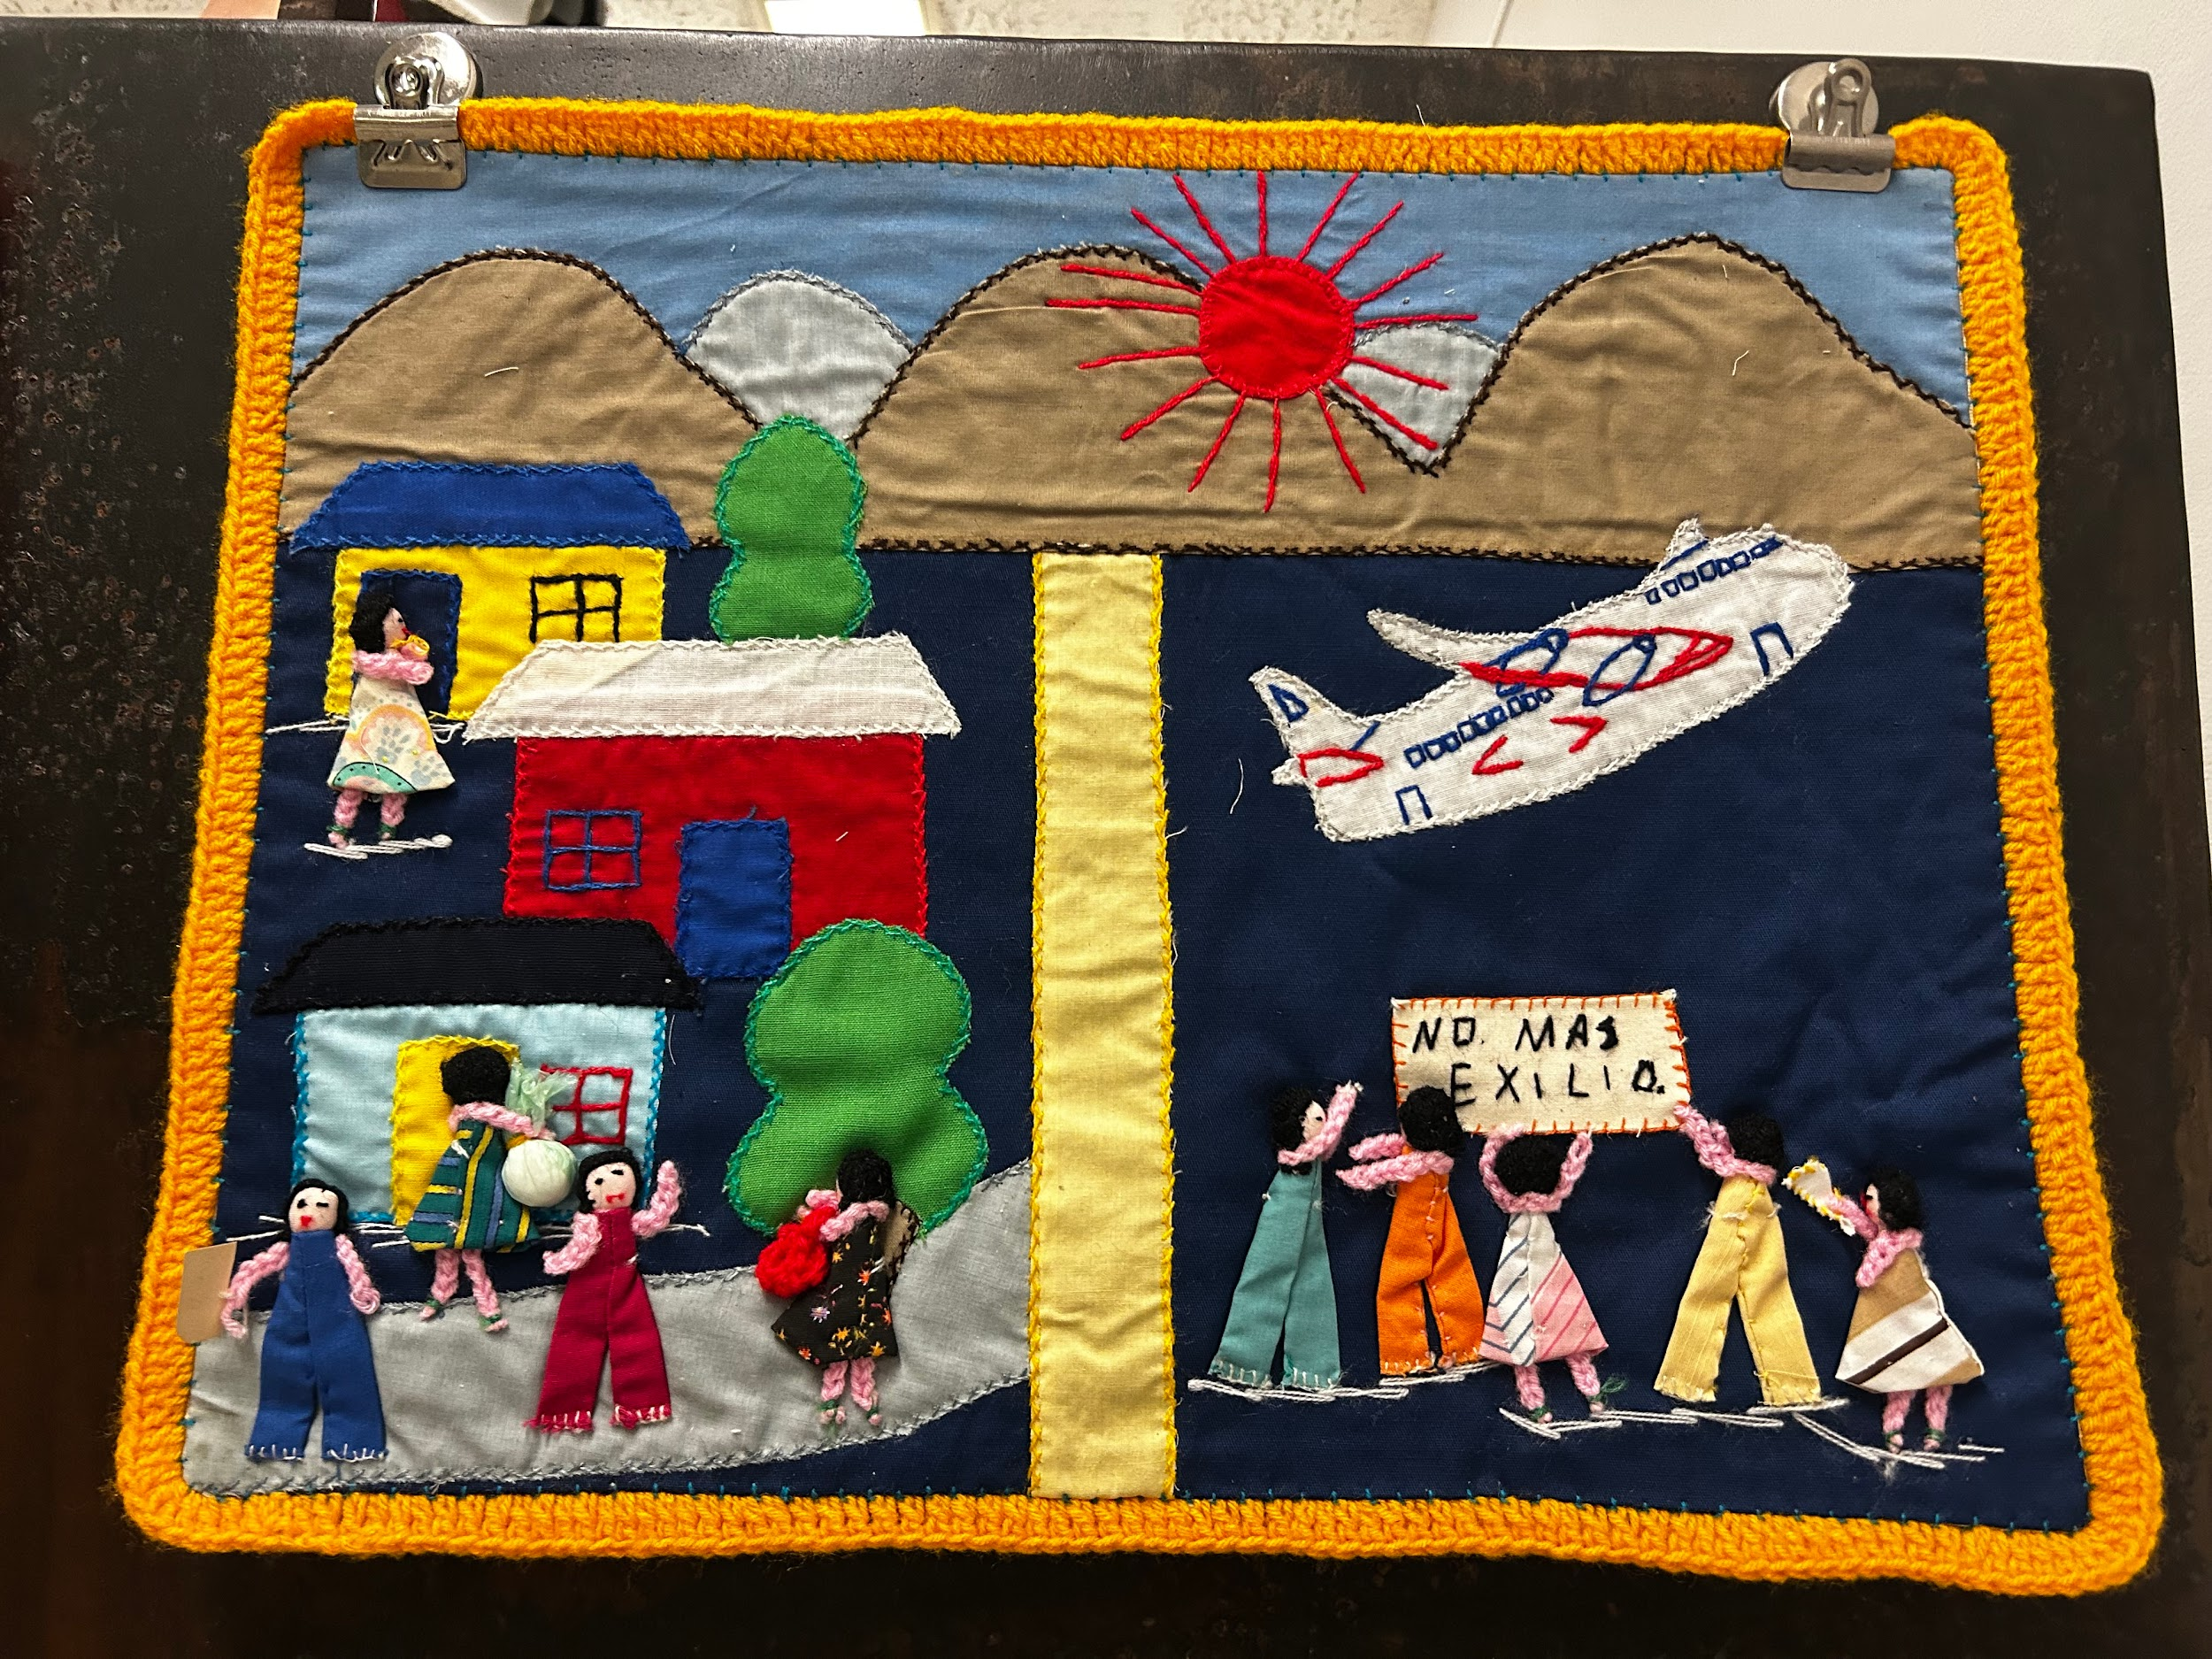

An Analysis of an Arpillera Depicting Deportation

Arpilleras were made by the wives, sisters, daughters, and mothers of the disappeared political rivals of the oppressive Pinochet Regime in Chile during the 1970s and 1980s. These pieces were used to document, protest, and resist the tyranny of having to live in fear of your relative or yourself being disappeared. Samples of historical documentation that include minimal or no text like this are valuable because they transcend the need for written language.

This specific arpillera appears to be divided into two halves, each showing the same view. On the left of the border, there looks to be a lively neighborhood, with trees, and colorful homes. However, above the border we see the mountains, the sun, and the sky. All features of Chilean geography which remind the viewer that a made up border or barrier ends within the abstract, hence its ending at the foot of the mountain. The physical features of the mountains and sun draw attention to the geographic importance of Chile. The mountain civilizations of the Andes peoples, and other Latin American societies, have used complex textiles for centuries to convey family, culture, history, economic, and spiritual status.

Still on the left of the border, several people are gathered outdoors in a public space, suggesting an element of everyday community life. The handmade figures made from fabric and yarn carry bags of goods and look to be involved in a conversation, maybe about work, family care, or current events. This half of the Arpillera represents home, belonging, and the social fabric of communities before they were torn apart by kidnappings.

Looking at the right side, the tone shifts dramatically. A plane flies above the heads of characters, away from the neighborhood. Below the plane are a group of people all holding the weight of a sign saying “No más exilio,” meaning no more exile. The airplane represents the harsh reality of mass deportations, executions, and exiles from the country. In the Pinochet era, many Chileans who were even slightly suspected of not bending their knee to fascism, such as dissidents, intellectuals, union workers, and ordinary people, were expelled from the country. There is a muddy history of the Pinochet regime, using deportations, disappearances, and murders to control the way that the Chilean population lived.

